**EDUCATIONAL ORGANAIZATION USING SERVICENOW**

**Team Id: NM2025TMID18054**

**Team Member: 4**

**TeamLeader : SIVAPERUMAL A**

**TeamMember1: BENAIAH ABIEZER S**

**TeamMember2:**

**NETHAJI R**

**TeamMember3: SARAN J**

**Problem Statement:**

Many educational institutions rely on manual or disconnected systems to manage students, staff, courses, and support requests. This causes delays, data loss, and lack of visibility. A unified ServiceNow platform can streamline administration and improve collaboration.

**Objective:**

To implement ServiceNow for streamlining IT services and administrative processes in the educational organization.  
To enhance service delivery through automation, centralized tracking, and a user-friendly self-service portal.  
To improve communication, efficiency, and satisfaction for students, faculty, and staff.

**Skills:**

Tensorflow

**TASK INSTRUCTION**

**Milestone 1:** **ServiceNow Instance**

**Activity 1: Setting up ServiceNow Instance**

**1. Sign up for developer.servicenow.com**

**2.** **Once logged in, navigate to the "Personal Developer Instance" section.**

**3.click on” request instance” to create a new Service now instance**

**4. Fill the given details**

**5.The service now website can be display.**

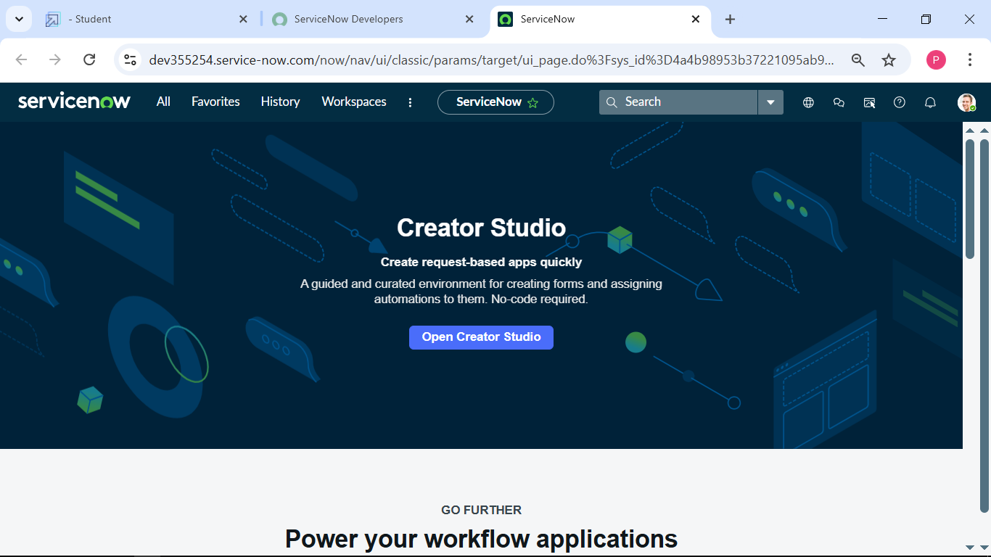

**Milestone 2: Update set**

**Activity 1: Creating Update Set**

**1. open service now**

**2. click on All and select Local Update Set**

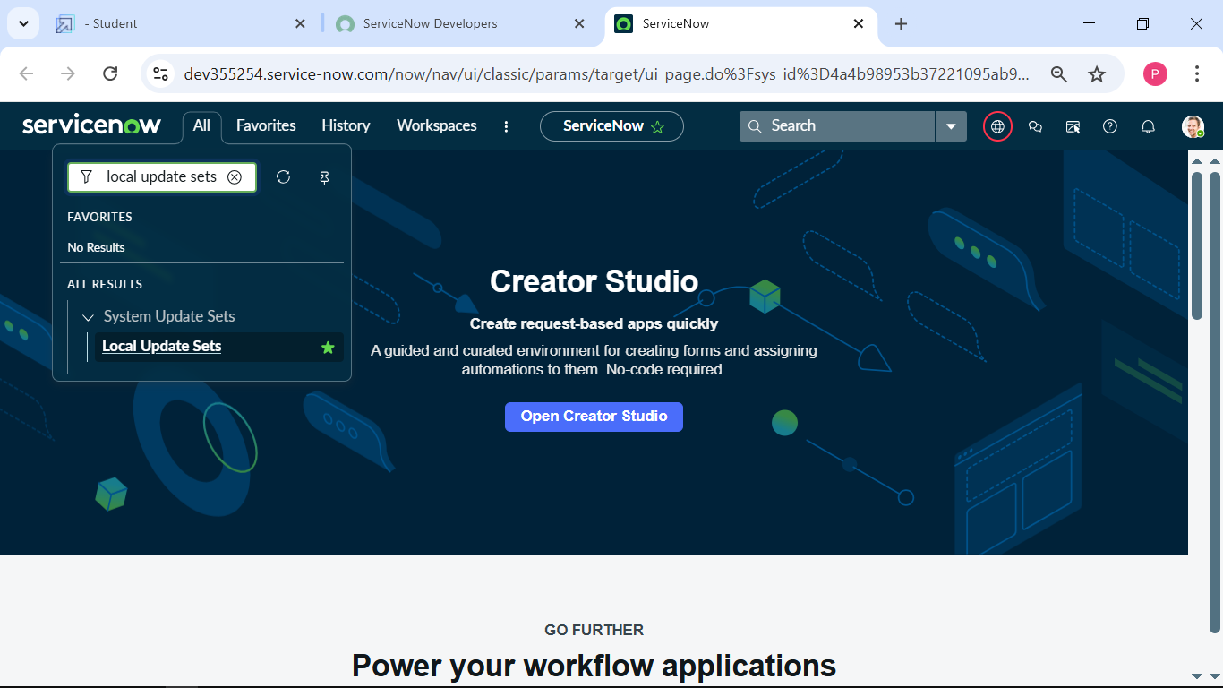

**3. click on new**

**4.Enter the details name : Educational organaization and submit .**

**Milestone 3: creating tables**

**Activity 1: Creating Firsttable**

**1. click All and select Tables.**

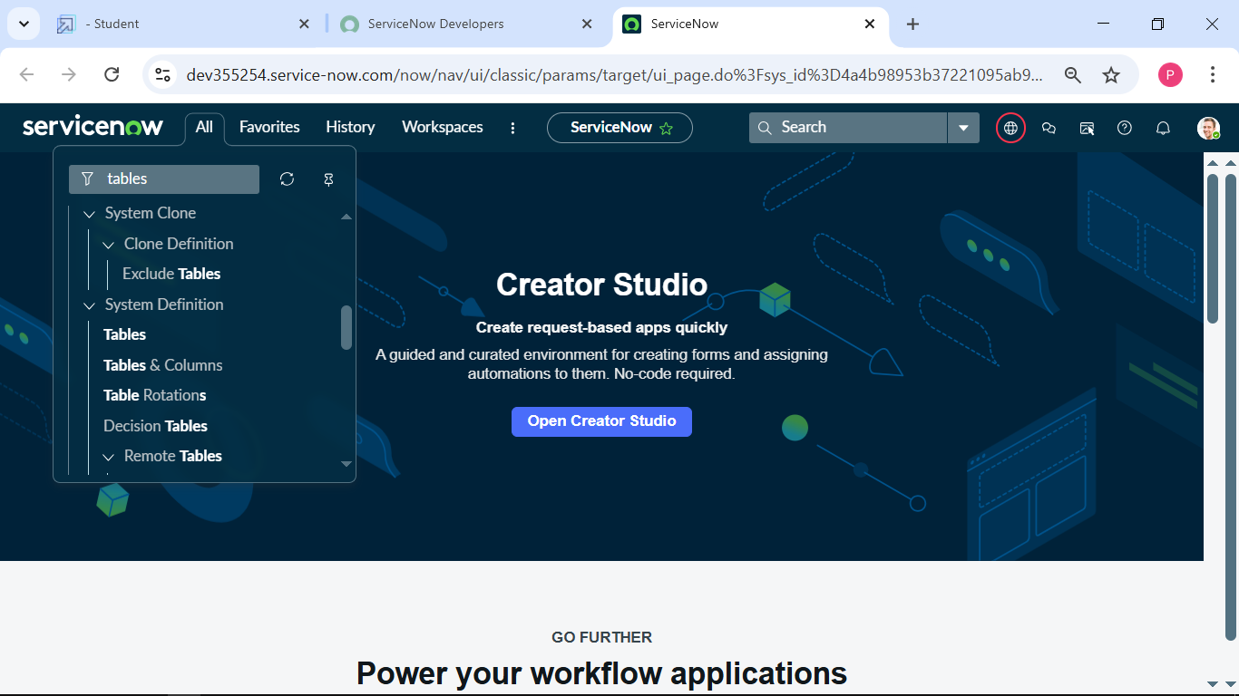

**2. click on new**

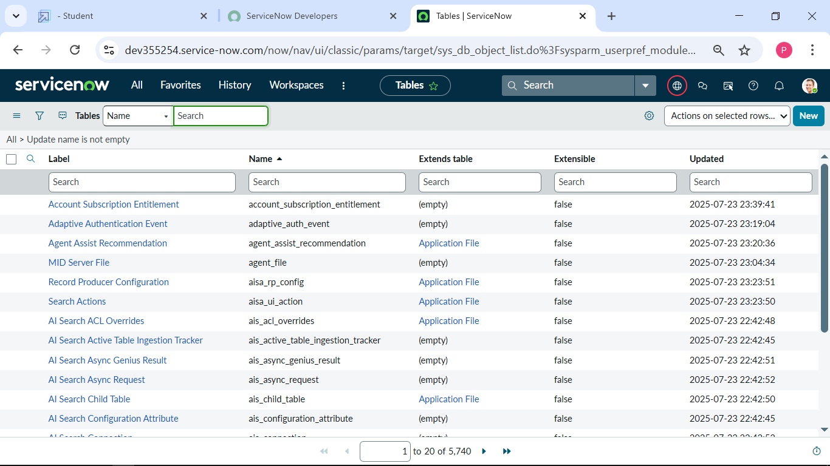

**3. Enter the label I enter First table and click on name it will automatically generate the name.**

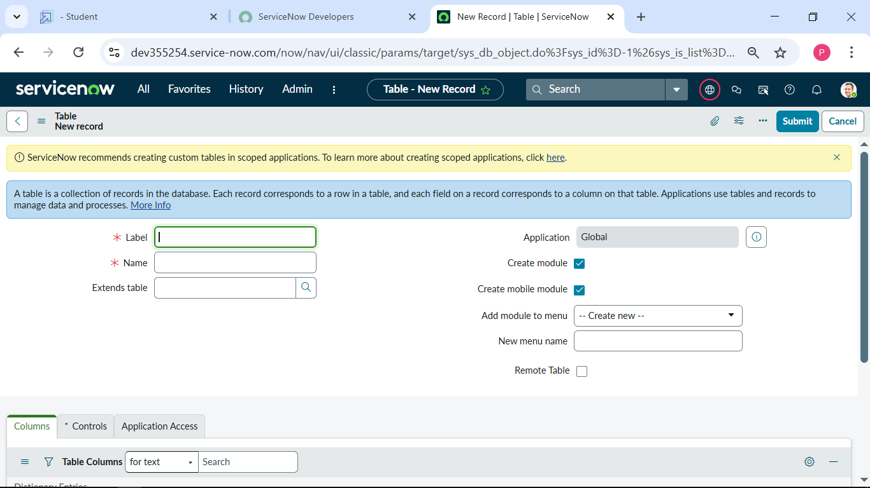

**4. After enter the details create a column double click and enter the column label and click a tick mark.**

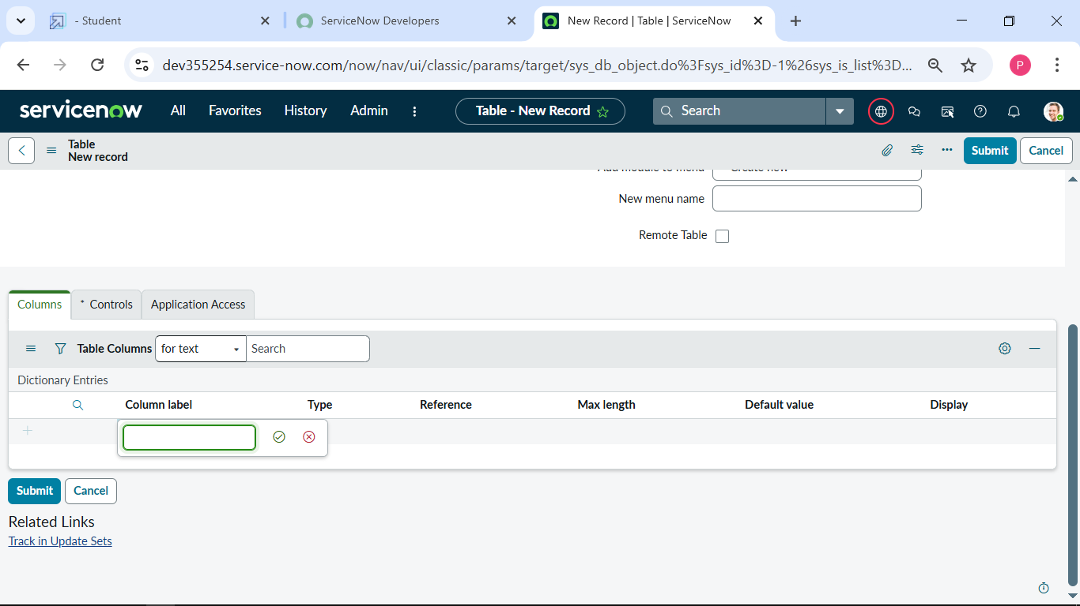

**5.click on toggle bar and save.**

**Create one more table:**

**Create another table as: Admission Table**

**1. Create a Admission table with given column.**

**2.** **Extends Table is First table and also Select Add module to menu on First table.**

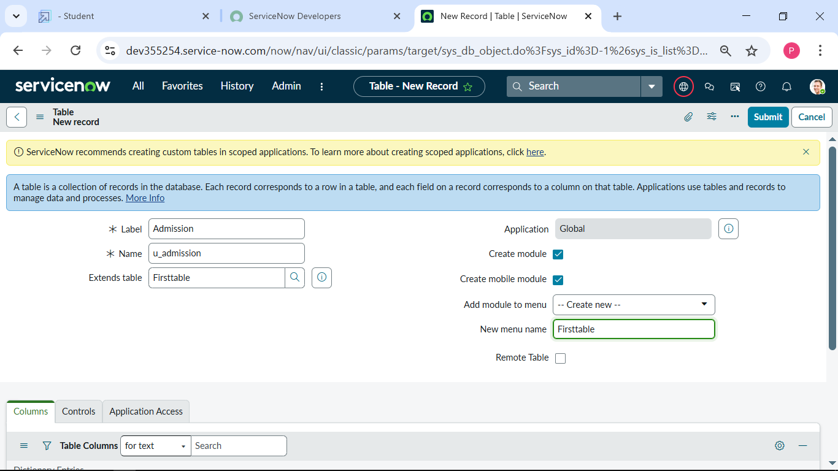

**3. Create a choice for Admin number ,Pin code ,purpose of join as ,school and school area .**

**Create one more table:**

**Create another table as: Student progress**

**1. Create a student progress table with given column.**

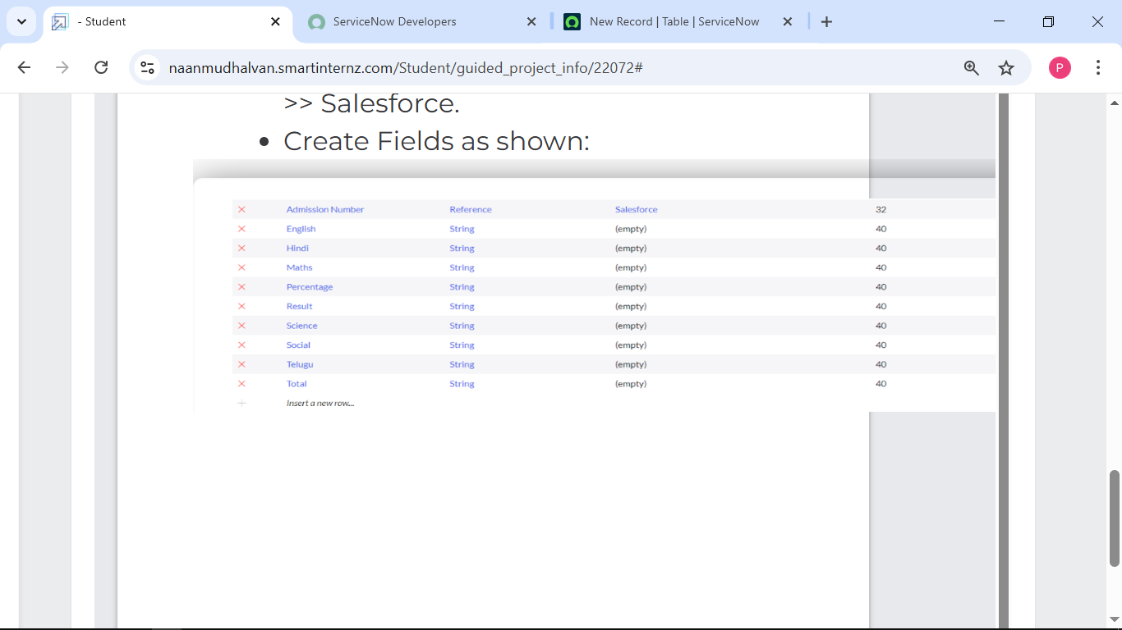

**2. Create Fiels as shown.**

**Milestone 4: Form layout**

**Activity 1: Configuring table form for student progress table.**

**1. In the student progress table page click on layout form.**

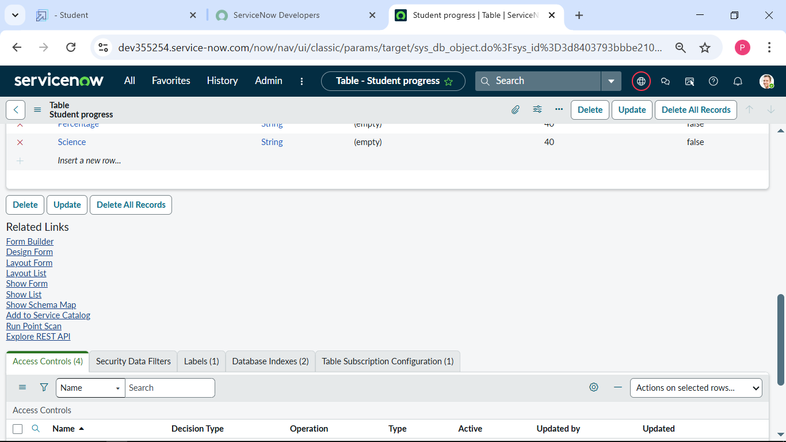

**2. Click on Admission Number.**

**3.**  **Select below Admission Number fields in Available side and send it to selected side as below and save.**

**Milestone 5: Form design**

**Activity 1: Creating Form design for first tabel.**

**1. Click on All and select Tables under system definition**

**2. In Label Search for First table and open.**

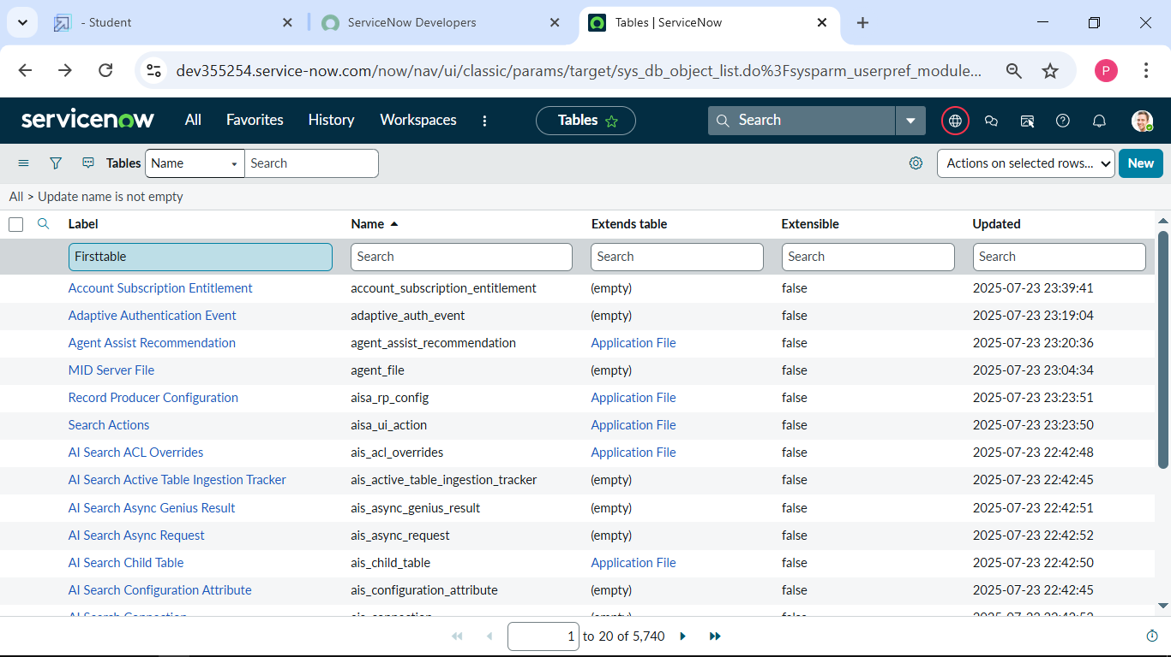

**3.** **Right Click on top Toggle select Configure and click Form Design.**

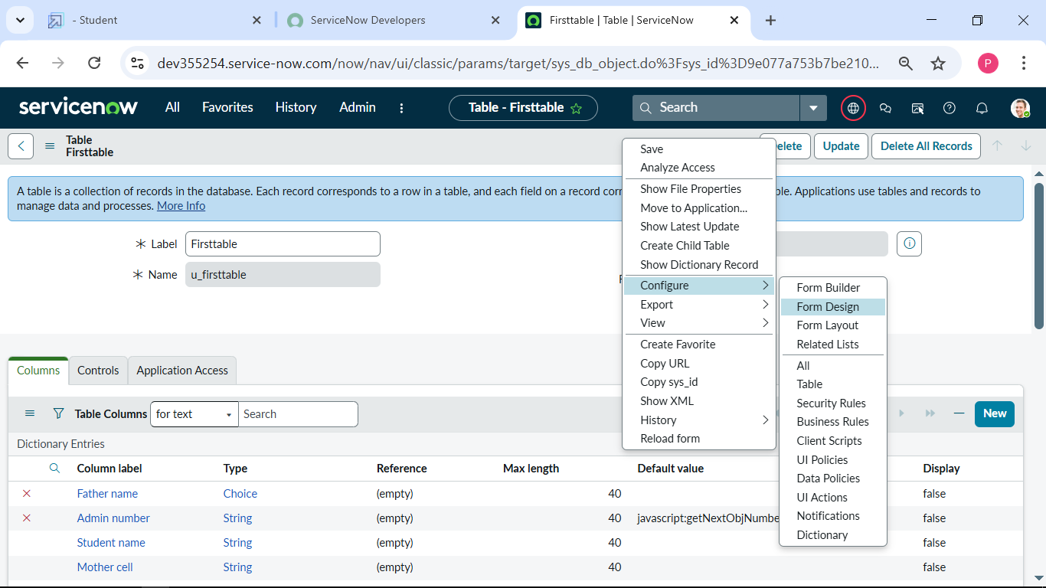

**4.** **In drop down select First table (u_ First table).**

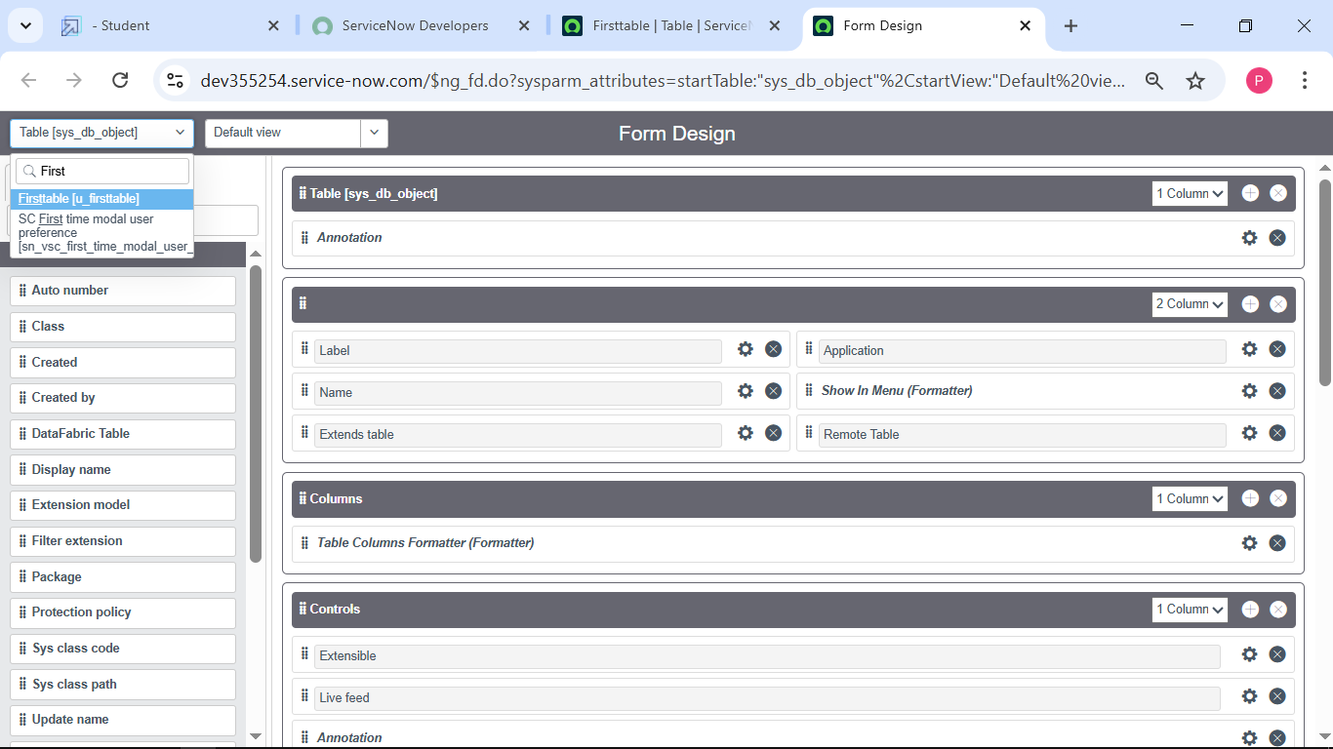

**5.** **Drag and drop the fields to the left side as below.**

**6.save**

**Creating form design for Admission table:**

**1. Follow the same Steps as Activity1, and enter given below the details and save.**

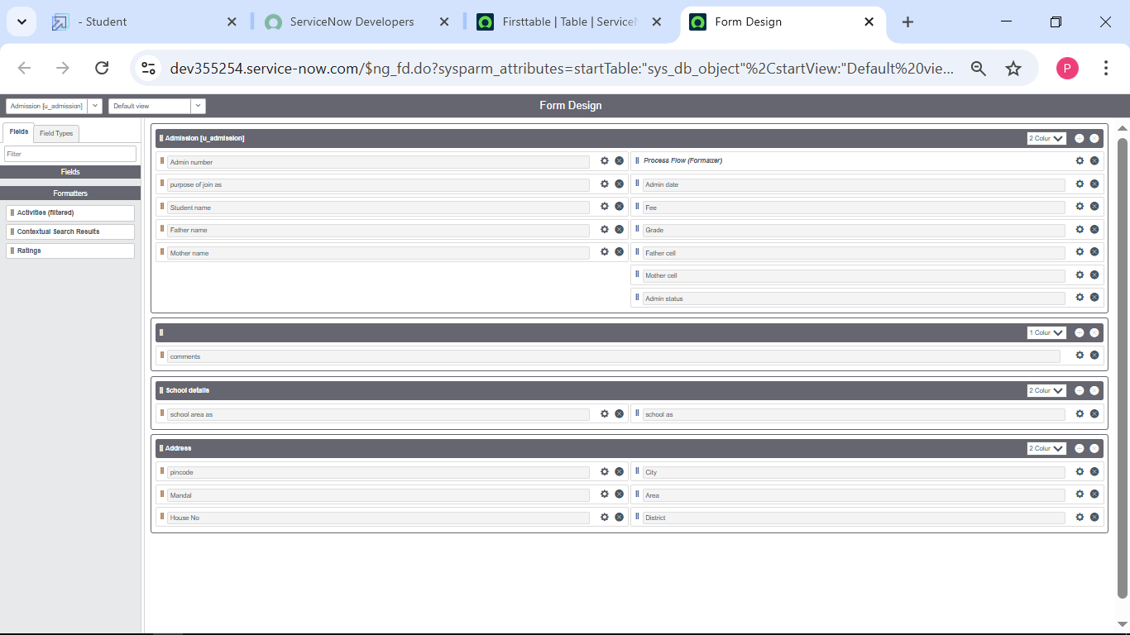

**Creating form design for Student progress table:**

**1.** **Follow the same steps as Activity1, Configure the fields as below and save.**

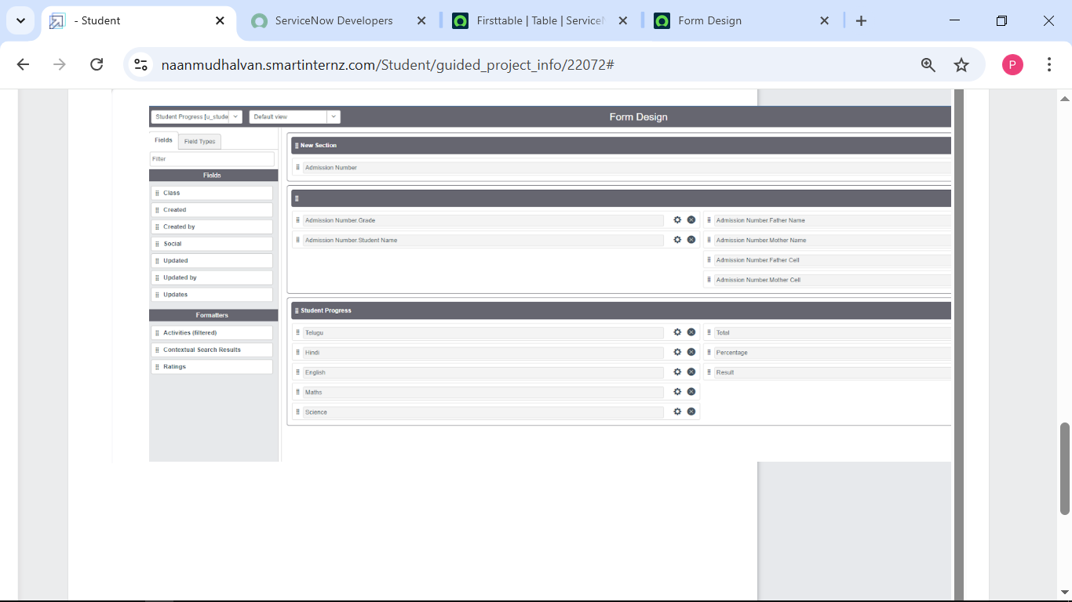

**Milestone 5: Number maintenance**

**Activity 1: Creating number maintenance for admission table.**

**1.Go to All select number maintenance and click new.**

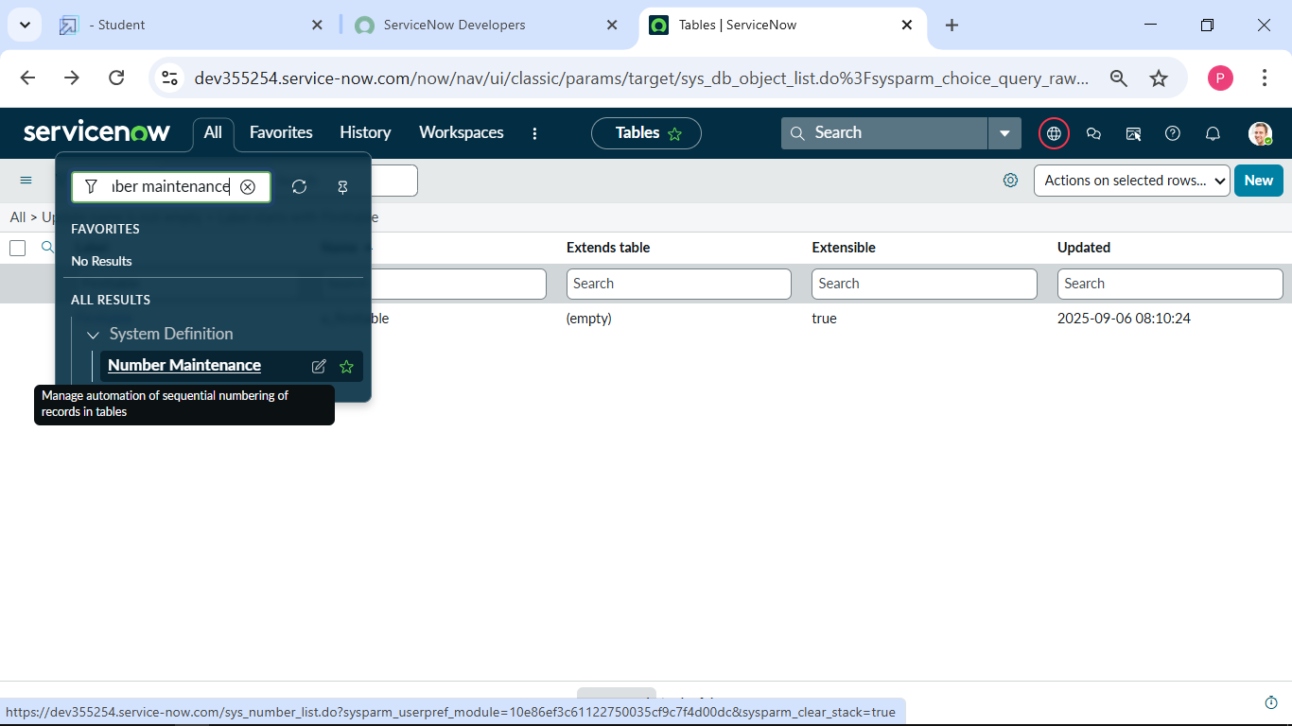

**2.fill the given details and submit.**

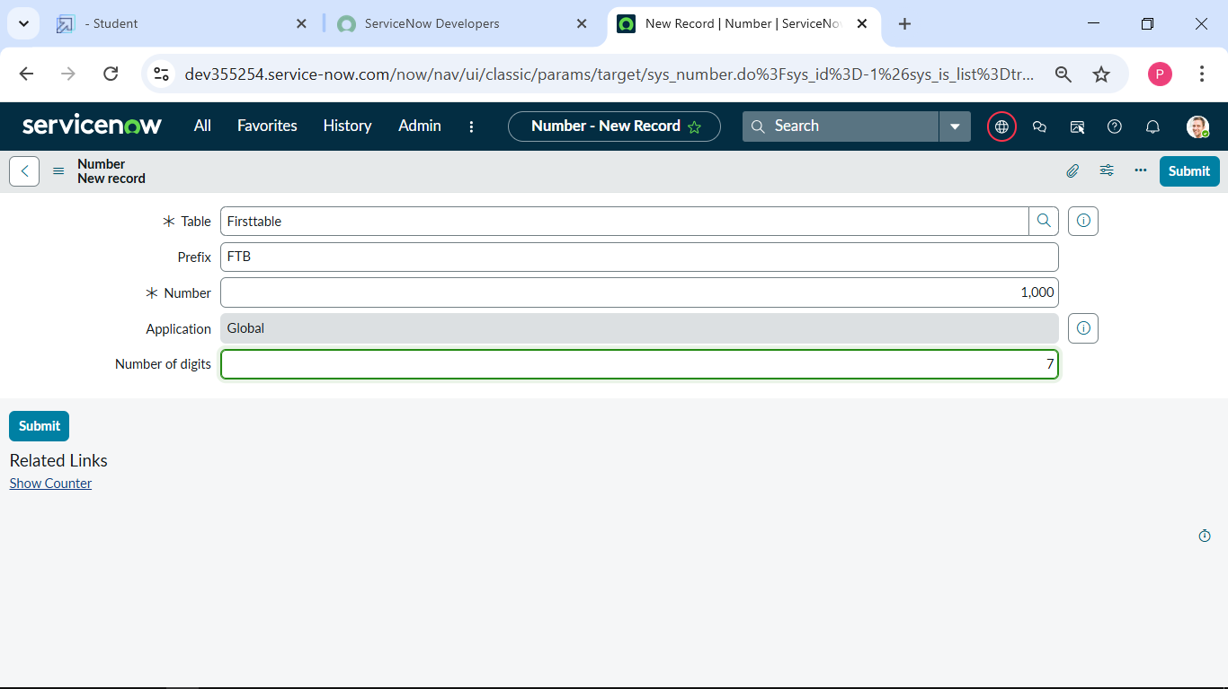

**Milestone 6: Process flow**

**Activity 1: Creating process flow for Admission table**

**1. Go to All and select process flow and click on New.**

**2. I fill the details as given below.**

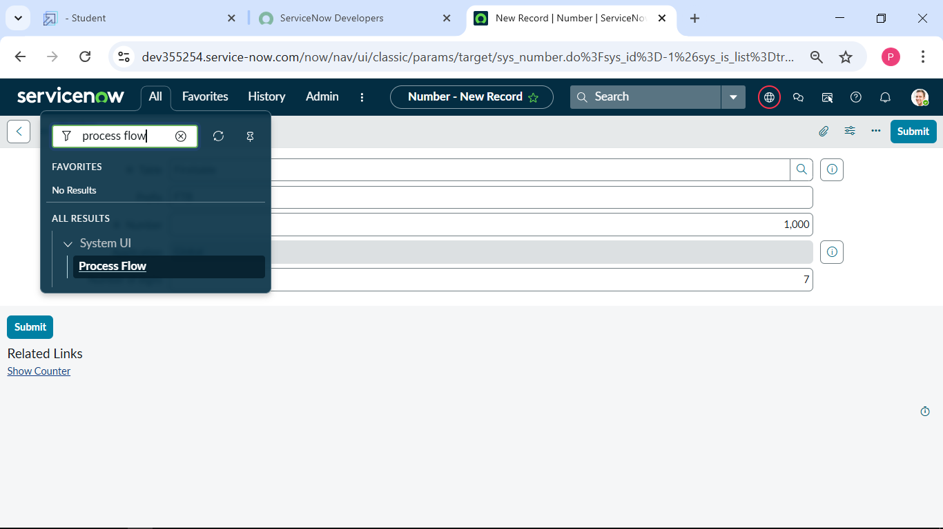

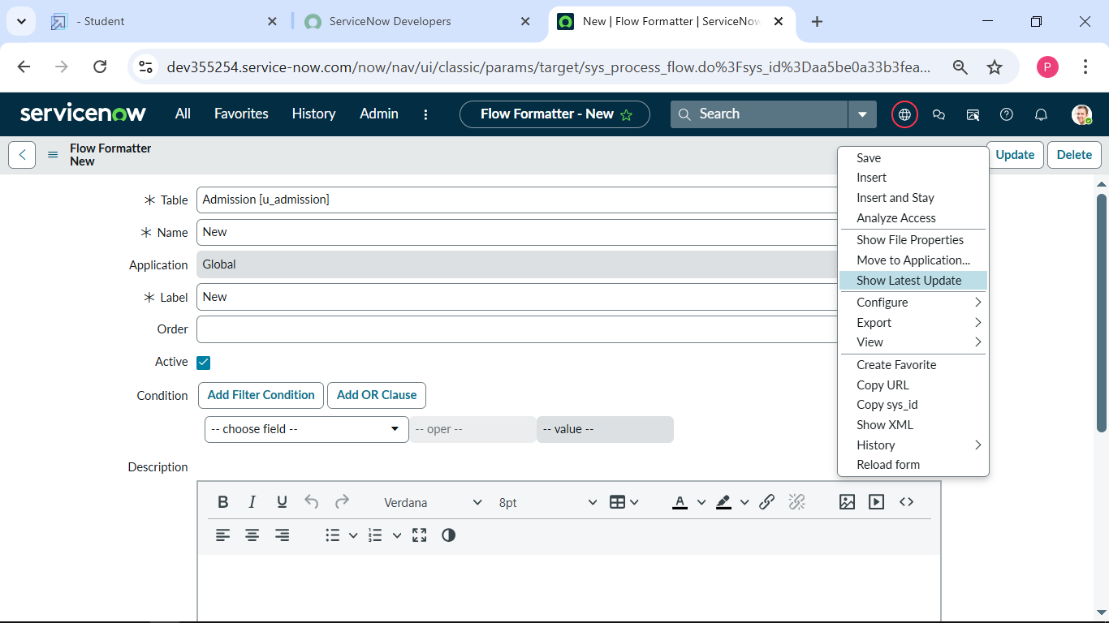

**3.save**

**4.** **Replace the Name and Label as below and click on Insert on stay.**

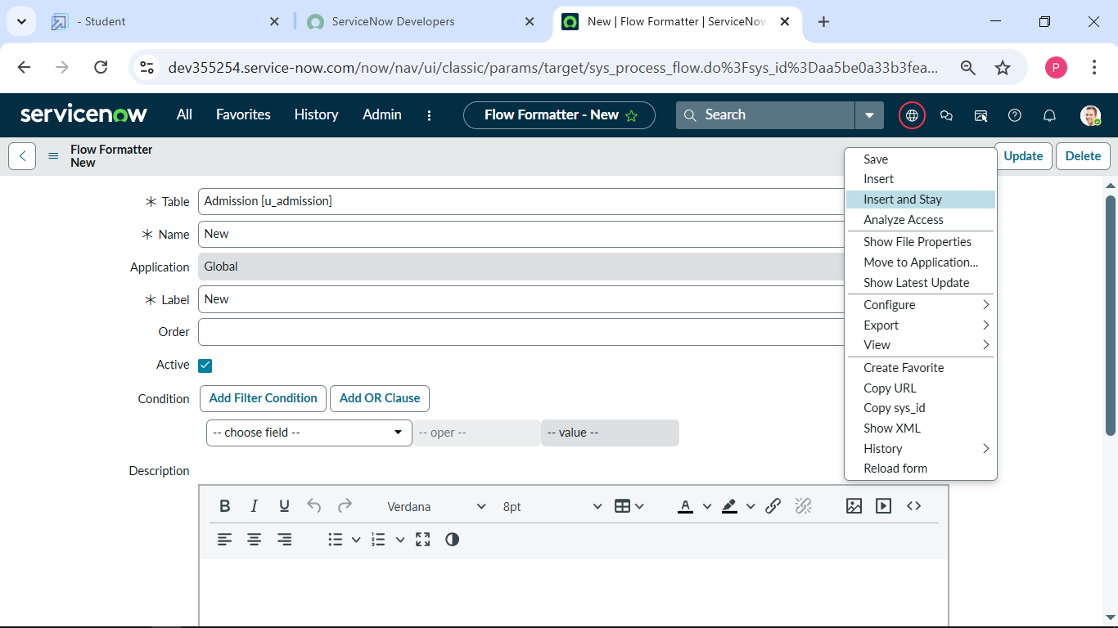

**5. Replace the Name and Label in order and click on Insert on stay.**

**Joined, Rejected, Rejoined, Closed and Cancelled.**

**6.** **Order should be New, InProgress, Joined, Rejected, Closed and Cancelled.**

**Milestone 7: Client script**

**Activity 1:” Auto populate “client scripts for Admission table**

**1. Go to All and select client scripts and click on New.**

**2. fill this below given details**

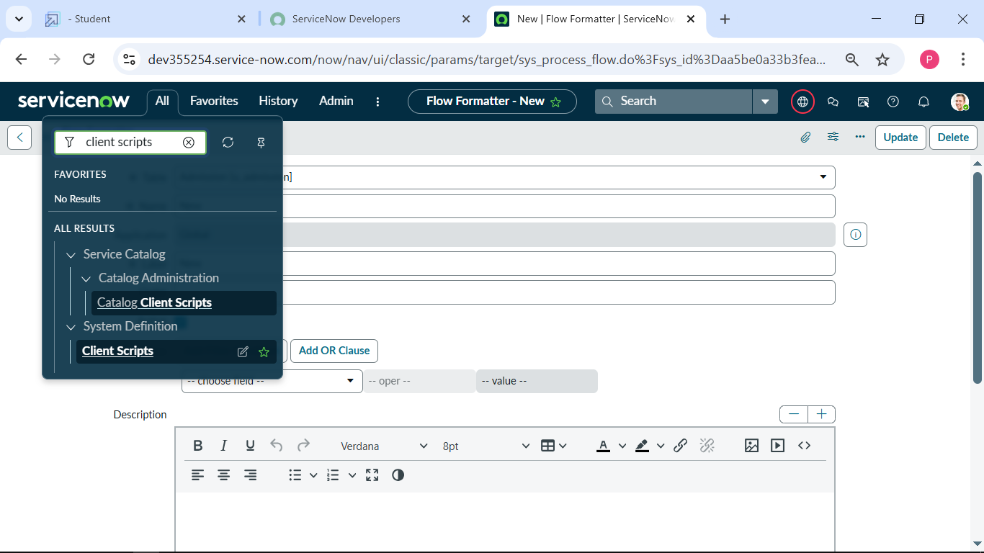

**3. Write the code and enable isolate and save.**

**Creating another client script “pin code update” for Admission table:**

**1. I filled the given details given as below.**

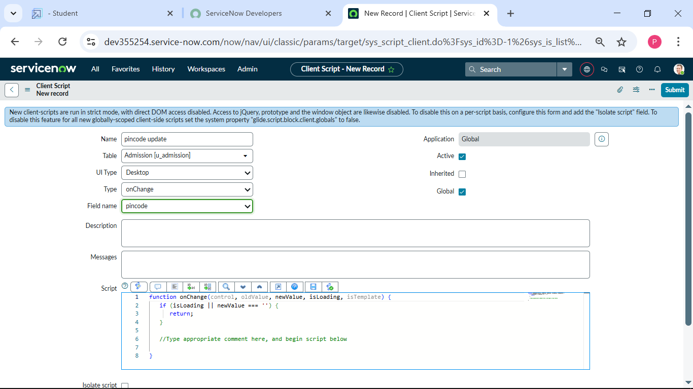

**2. written the code as below and enable isolate script and save.**

**Creating another clint script “disable fields” for student progress table:**

**1.I fill the details as given below.**

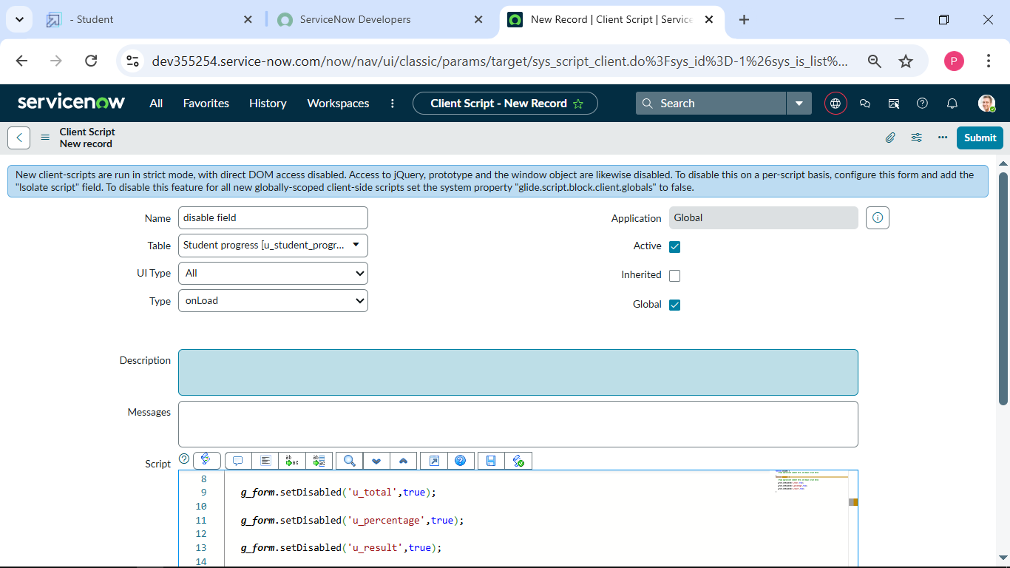

**2.** **Write the Code as below, Enable Isolate script and save.**

**Creating another client script” total update “for student progress:**

**1.I fill the details as given below**

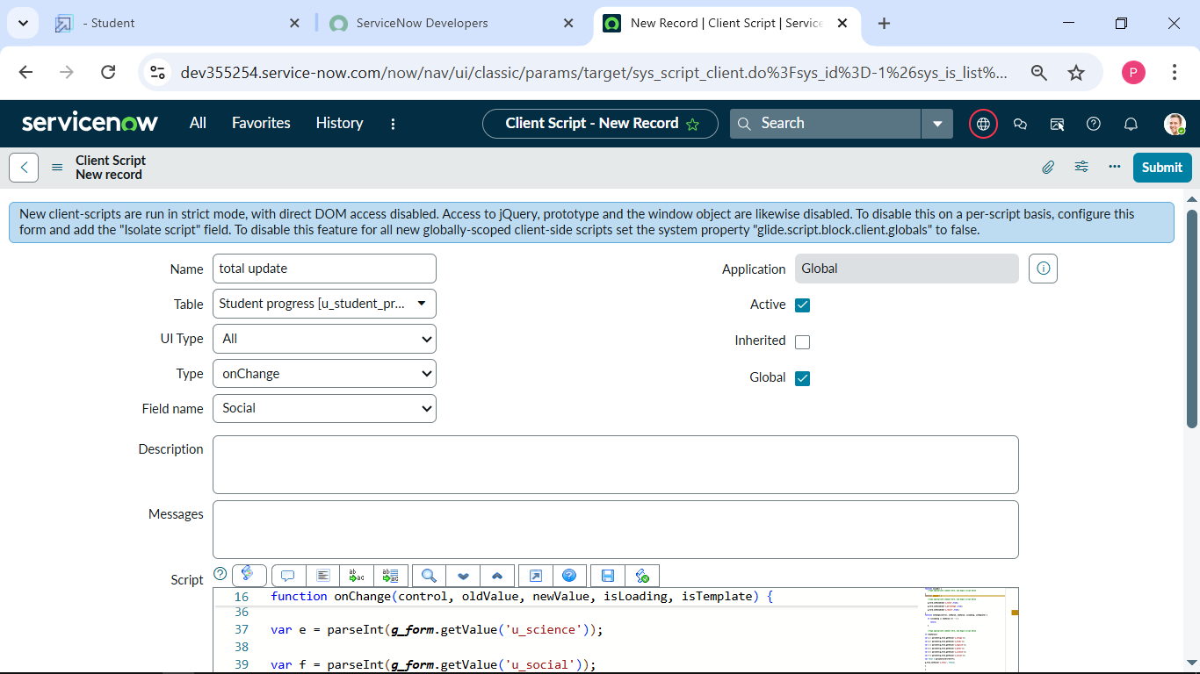

**2.** **Written the Code as below, Enable Isolate script and save.**

**Creating another client script “Result” for student progress table:**

**1.Fill the details as given.**

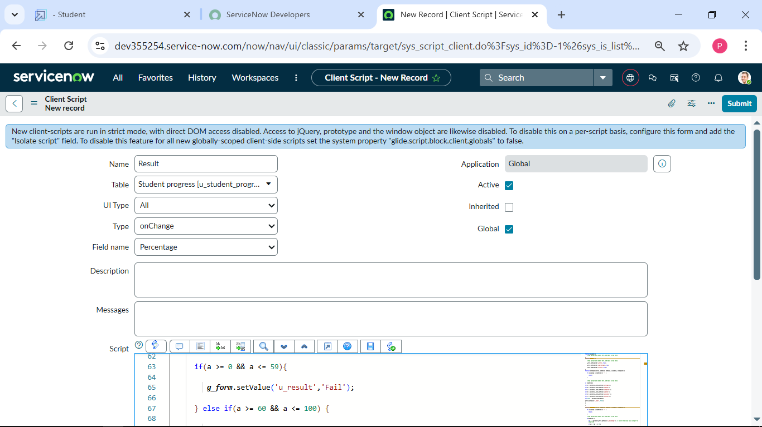

**2.** **Written the Code as below, Enable Isolate script and save.**

**Creating another client script” percentage” for student progress:**

**1. I Fill the details as given below.**

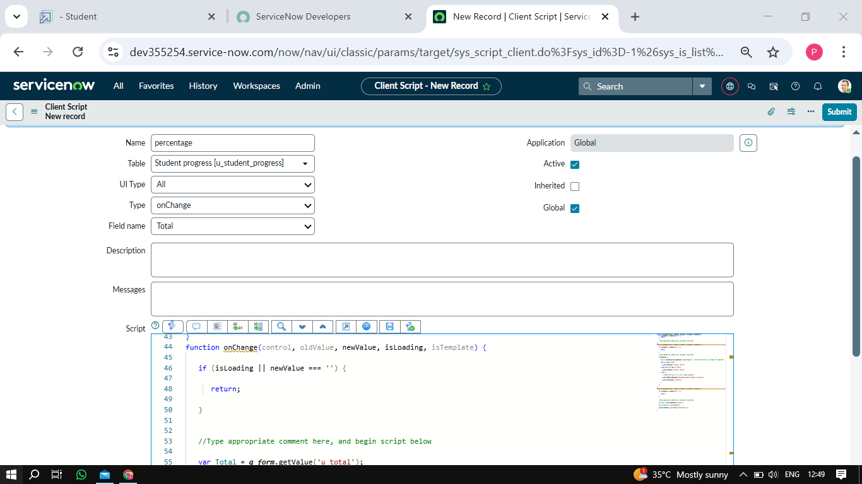

**Conclusion:**

**Implementing ServiceNow will significantly improve operational efficiency, streamline workflows, and enhance service delivery in the educational organization.  
The centralized platform will foster better communication and collaboration among departments, ensuring faster resolution of requests.  
Ultimately, ServiceNow will provide a seamless experience for students, faculty, and staff, supporting the organization's growth and innovation.**